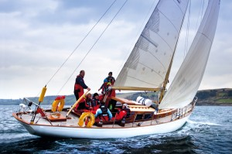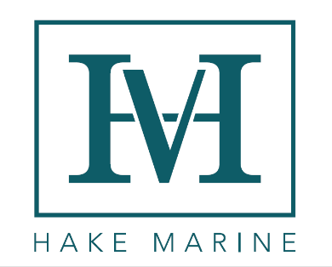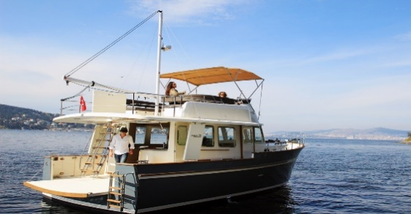

Save a Classic

Hake Marine, builders of Island Packet, Seaward and Blue Jacket Yachts, is excited to announce the introduction of our new and improved Refit program. This program will allow you to pick your dream boat and have it either partially or fully restored by the best craftsmen in the business! The exciting thing is we will refit ANY BRAND OF BOAT out there! Yes that’s right any brand power or sail we will refit your boat and return her to you like new. The quality of the Island Packet and Seaward lines have been known in the industry for years. Now you have a unique opportunity to have the best boat builders on the planet refit any boat of your choosing. The refit will be far less expensive than buying new and you will own a unique classic that will be refit to modern ABYC standards and the highest quality available. We will even assist you finding and buying your dream boat to have refit with us. Who better to have on your side when buying a used boat! We here at Hake Marine love boats old and new. We love the history of them and love to save them! If you are in the market to buy a boat, you want to save a piece of history and some money, give us a call and let us help you find your dreams.

*“Twenty years from now you will be more disappointed by the things you didn't do than by the ones you did do. So throw off the bowlines. Sail away from the safe harbor. Catch the trade winds in your sails. Explore. Dream. Discover.”*  Mark Twain

Please contact Jeff Mack at Hake Marine for details.

[jeffreyamack@gmail.com](mailto:jeffreyamack@gmail.com) 727-724-4557